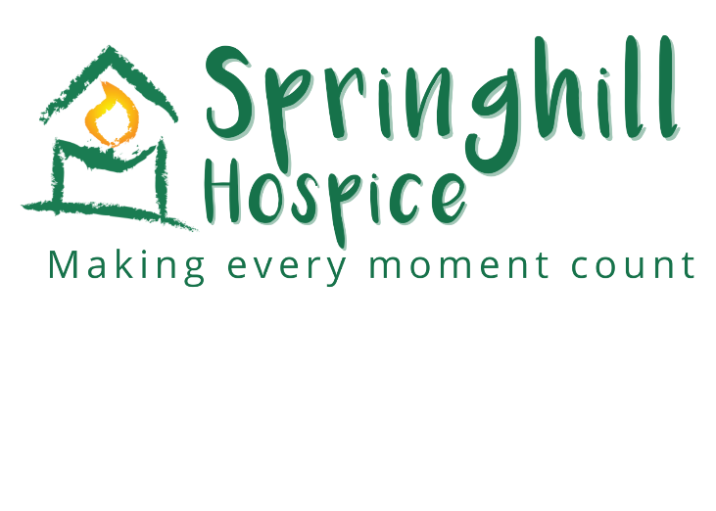

**Name:**

**I like to be known as:**

**Please help me to complete my**

**Life Story Book.**

**It will help us to get to know each other, and provide me with something familiar. We may even find we have things in common!**

**It should help to calm my mood, and give us lots to talk about.**

**It may also help to build a special trust between us, and most important of all …**

**My Life Story Book**

**will help us to have fun together 😊**

**Introduction to my life**

**Date of Birth: ___________________________________________________________________**

**Place of Birth: ___________________________________________________________________**

**Family:**

Mothers name and occupation:

Fathers name and occupation:

Position in family: (i.e. oldest, youngest etc.)

Names of sisters and brothers: (eldest first)

Grandparents or other family members:

Relationships

You could include: parents, grandparents, children, siblings, husband or wife, Partner, friends or pets.

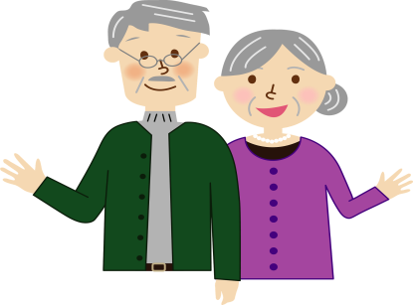

My Childhood

You could include: where you lived, memories of school, lessons and teachers, toys and games.

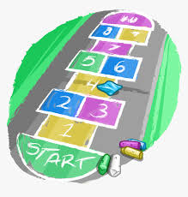

My Work life

You could include: first job, favourite job, a job you disliked or loved, a job you would like to have done, work colleagues.



Special Places

You could include: a special place you lived, holidays, outings, where you would like to have visited, other places important to you.



Beliefs

You could include: religious or spiritual beliefs, places of worship that are important to you.

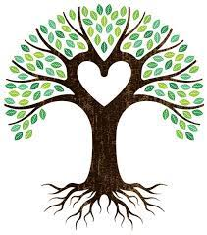

Pets

You could include: pets you or a family member have loved.



Smells

You could include: your favourite food, perfume, flowers, smells that remind you of happy times.

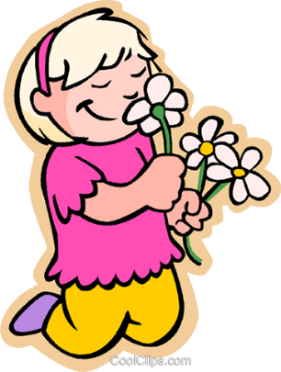

Clothes Like to Wear

You could include: a special hat, dress, shirt, pair of slippers.

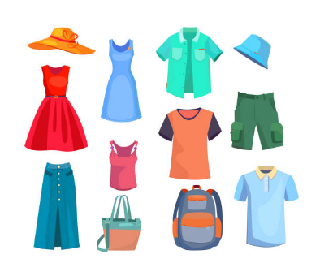

Special Life Events

You could include: marriage, birth of children, loss of loved one, birthdays, religious occasions.

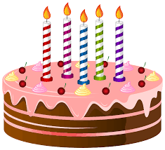

Social Activities

You could include: sports, going to the pub, bingo, shopping, cinema, walking, eating out.



Hobbies and Interests

You could include: favourite T.V programmes, radio, music, books, arts and crafts, gardening.



Likes and Dislikes

You could include: food and drink, clothing, activities, smells, technology, subjects you like or don’t like to talk about.

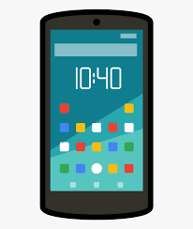

Makes me Happy

You could include: places you like to visit, favourite music, special people, things you like to make or do.



Makes me Sad



Things Important to Me



My Life Now

You could include: things that are important to you now, food and drink, appearance, clothes, hair, nails, routines. Do you need help or support?



“I Know I Feel Well When I …”



**Springhill Hospice**

Broad lane

Rochdale

OL16 4PZ

01706 649920

[www.springhill.org.uk](http://www.springhill.org.uk)

Incorporated as a Company Limited by Guarantee No 2325905

Registered Charity No 701798

This booklet was created using information from:

Dementia UK

Margaret Diggle