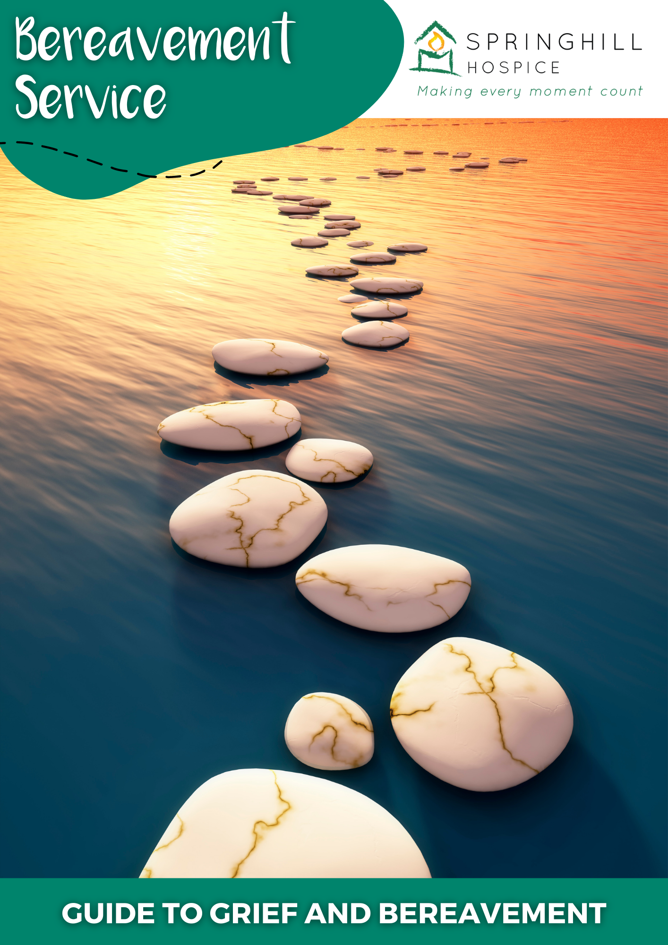

Index of Contents

Heading | Page number
Before you Start | 3
Introduction | 4
Bereavement and Grief | 5
Effects of Grief  Feelings  Thoughts  Physical Wellbeing  Behaviour  Exercise 1 | 6
Ways of Looking at Grief and Bereavement  The Grief Wheel  Exercise 2  The Whirlpool of Grief  Tasks of Mourning  The Dual Process Model  Growing Around Grief  Exercise 3 | 12
When Grief is Complicated | 16
Grief and Your Relationships | 17
Who have you lost?  Partner  Parent  Child  Sibling  Friend | 18
Talking to Children About Loss | 20
Bereavement from Causes Other than a Life Limiting Illness | 21
Taking Care of Yourself in Your Grief  Exercise 4  What Helps? | 22
Not Being Able to Say Goodbye | 27
Religion, Faith and Spirituality | 27
Deciding if you Need Further Help and Support. | 27
Specialist Bereavement Services | 28

Springhill Hospice Bereavement Service
Guide to Grief and Bereavement

Before you Start

This guide is intended for use by people who have experienced a bereavement where someone has died from a life-limiting illness.

Grief is a normal reaction to the loss of a loved one, and whilst it can be very distressing it is not a mental health problem by itself. However, it may trigger mental health problems or make existing problems worse.

If you are feeling very distressed, suicidal, or in need of immediate support there are services who can help.

You can phone the Samaritans on 116 123
Contact your GP during working hours
Contact the NHS 24 hour 111 service out of hours
Call 999 for an emergency ambulance.

At the back of this guide you will find a comprehensive list of sources of help and support through bereavement and grief.

Introduction

The aims of this guide are to help you to:

- Understand the process and experience of grief

- Find ways to cope with the effects of grief on your thoughts, feelings, behaviour and physical wellbeing

- Decide if you need further help to cope with your grief and suggest some possible sources of support.

You may choose to read the guide simply as a source of information.

However, we have included some educational sheets and exercises that are often used to help people to look at their grief and how they are responding to it. Some of these may be familiar to you whilst others may not. We hope that they will be helpful for you to work through to explore your loss, but there is no obligation to do so.

Bereavement and Grief

Bereavement is the loss of someone close and grief is our reaction to this loss. Grief means different things to different people, and there is no right or wrong way to feel. The death of someone close can be very distressing, and bring unexpected and powerful emotions. Everyone copes with their loss in their own way.

You may feel that you “should” start to feel better within so many days, weeks or months but there is no time limit on your grief. There may be pressure from other people to get on with your day to day life and to be able to deal with your usual responsibilities but it’s important to take whatever time you need to deal with your grief.

Your recovery from grief will probably be gradual and you may not notice it happening. Things tend to become easier over time, but it can be very hard to believe that this will happen when your grief is new and extremely painful. If you have lost someone close you may never “get over” the loss but your grief will change and become more bearable.

As you read this guide you will learn about the process of grief and its impact on you. We hope that this knowledge will help you understand what you are experiencing now and how your grief is likely to progress in the future.

Effects of Grief

In this section of the guide we will look at how grief can impact on your feelings, thoughts, physical wellbeing and behaviour. Grief is a normal, natural, emotional healing process that occurs after a significant loss. Although grief is unique to each of us it can be helpful to understand some of the normal reactions which people commonly experience in their loss. These reactions can be categorised into feelings, thoughts, physical wellbeing and behaviour. When you compare your experience with that of others, do remember that not everyone will experience all of these reactions. Signs of grief will vary from person to person, as will their order, intensity and duration.

Feelings.

You may experience a lot of complex and overwhelming emotions following your loss. These may include:

Sadness
Sadness is the most common emotion expressed by bereaved people. It may mean that you feel tearful and cry more often than usual.

Anger
Anger is common following loss and it can seem confusing. You may be angry towards the deceased person for leaving you. Anger may be directed towards other people such as medical professionals, family members or even God. You may be angry towards yourself if you feel that you could or should have done more to prevent the loss.

Guilt and Self Reproach
You may feel guilt over something that happened or that was neglected around the time of death; “Was I kind enough?” or “Could I have done more?”.

Anxiety
This can range from slight insecurity to strong panic. Anxiety usually comes from one of two sources: doubting your ability to cope without your loved one, or a heightened sense of your own mortality.

Loneliness
This is often experienced by bereaved people, especially if you have lost a partner or someone who was closely involved in a day to day relationship.

Helplessness
You may feel a loss of control or that you are helpless in the face of your new situation. This is especially common in the early stages of loss.

Shock
This occurs most often in the case of sudden loss, but can also occur when the deceased person has had a long illness but death has come unexpectedly. It may be accompanied by a sense of numbness or unreality.

Yearning
This is a longing for the person that you have lost and my also involve searching behaviour, or returning to places that have had a significance to you both. When yearning becomes less powerful if may be a sign that your grief is changing.

Relief
This is often felt where there has been a long illness, and especially if you feel that your loved one suffered. However, feelings of relief can often be accompanied by guilt.

Thoughts

Many newly bereaved people say that their thinking is confused and that they cannot order their thoughts. It is very common to experience difficulty in concentrating. You may be much more forgetful than usual.

You may find that you have thoughts like this:

- “It’s my fault” or “It’s the Doctor’s fault”. It’s common to search for someone or something to blame for your loss.
- “I must have done something to deserve this”
- “It’s not fair that I’m alive when they are dead”
- “I should have told them that when they were alive”
- “I shouldn’t have said that, and now it’s too late to make it right”

In addition to these thoughts you may feel a sense of the presence of your loved one. Hallucinations, both visual and auditory, are very common, especially in the first few weeks after bereavement. Sometimes these may seem frightening, but they can also be comforting.

Physical wellbeing

Most people who are grieving do not need to visit a doctor because grief is not an illness. However, grief can often cause physical symptoms and if you are concerned about them you should contact your GP. Common physical symptoms include:

Sleep Difficulties
You may have difficulty going to sleep, staying asleep, early waking or feeling that you are sleeping too much. Sometimes bereaved people fear their dreams, or fear that they may not wake.

Appetite Disturbance
This may be overeating or undereating.

Anxiety symptoms
People often report feelings of panic, fear and shakiness. You may notice tightness in your chest and breathlessness. People sometimes feel as though there is a physical weight on their chest.

Tiredness
You may experience weariness and lack of energy.

In addition to the above you are more likely than usual to develop infections or other health problems because of the stress which your body is experiencing. If you are worried about your health you should contact your GP who will be able to decide if you are suffering from an illness or if it is grief which is producing your symptoms.

Behaviour

Social Withdrawal
Following a loss it’s not unusual to become socially withdrawn, not wanting to go out or to see other people. This can include a general loss of interest in the outside world and you may stop following the news or watching television.

Avoiding Reminders
You might find that you avoid going to places that remind you of your loved one, as they trigger painful feelings of grief. You may also try to avoid talking or thinking about the person that you have lost.

Crying and Tearfulness
Some people experience weeping, sobbing or uncontrollable crying, whilst others feel a need to cry but aren’t able to do so.

Exercise 1

You may find it helpful to think about the normal manifestations of grief which have been described above and see which ones seem to be relevant to you. It can sometimes be useful to write things down in order to understand how you are thinking and behaving.

If you wish you could use the table on the next page to look at how you have been reacting to your grief. It may help you to understand how your feelings, thoughts, physical wellbeing and behaviour all interconnect and affect each other. If you make a list of things that help you to cope with your grief it may enable you to build more of these into your life.

Feelings | Thoughts | Physical wellbeing | Behaviour
Things that help me to cope with my grief.

Ways of looking at grief and bereavement

There are many ways of looking at grief, some of which may be familiar and others will not. People used to describe bereavement as a series of stages which people went through. Elizabeth Kubler-Ross, a psychiatrist in the 1960s, described five stages of dying:

- disbelief
- anger
- bargaining
- depression and
- acceptance.

These stages have been adapted to help people look at the feelings they experience after a bereavement. All of the words used for the stages are useful in describing grief, but it is not always helpful to look at your grief in this way, as some people will not experience all of the stages, and often feelings happen in a very untidy way, with frequent movement between the five stages.

The Grief Wheel also describes grief as happening in stages, but is a much more flexible way of examining your feelings. Grief is seen as a process which allows for movement both backwards and forwards in your grief, but always with the emphasis on a gradual movement towards finding a new “normal” way to live without your loved one.

Exercise 2.

If you look at the copy of the grief wheel on the next page, you could think about where you would place yourself on the wheel at the moment. Remember that it’s normal for you to find yourself moving in both directions. This may happen particularly following another challenge or loss in your life, such as another bereavement or the ending of a relationship.

You may be able to see that you are no longer in the initial “shock” phase of your grief, as people tend to ask for support in in the middle of their grieving process. Perhaps you could think about which of the words on the diagram apply to how you feel at the moment and you could also add your own words to describe your feelings.
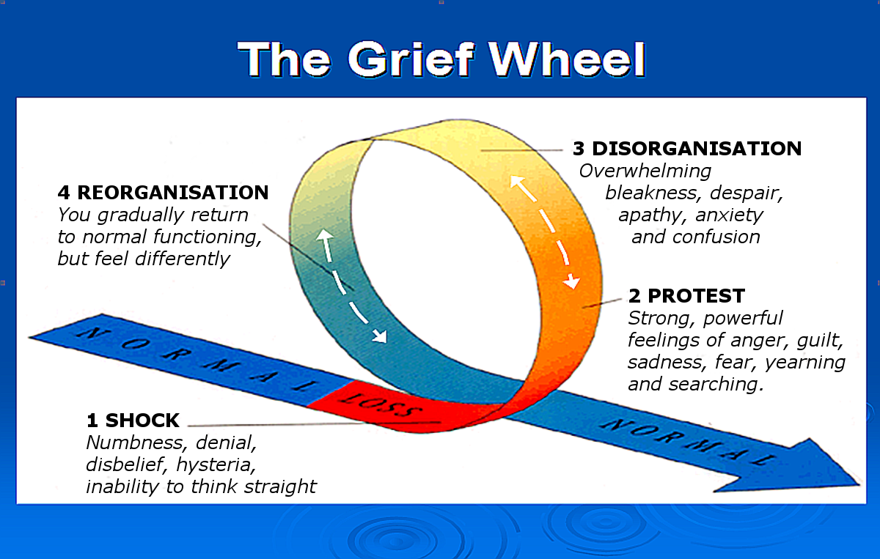

Other models of grief describe a journey through the grief process where you are tossed about from one set of emotions to another, but eventually come through your turmoil and emerge into a calmer place. This is shown in ‘The Whirlpool of Grief’ below.

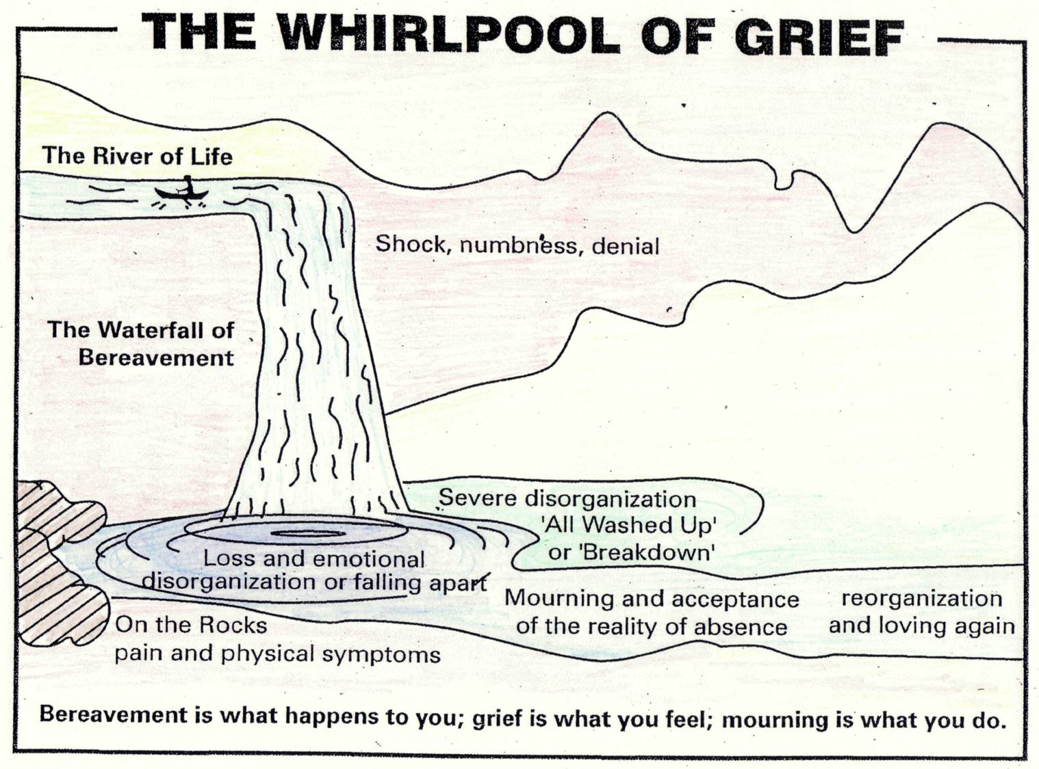

Some models of grief suggest that there are certain tasks that have to be performed for us to reach the end of our period of mourning. These models are generally based in the work of William Worden, in the 1980s. He suggested that there are four ‘Tasks of Mourning’. The ideas which he suggested changed over time, but can be summarised as:

Task 1. To accept the reality of the loss
Task 2. To work through the pain of grief
Task 3. To adjust to the world without your loved one in it.
Task 4. To find a way to maintain a connection to the person who died whilst embarking on your own life.

There are more modern ways of thinking about grief which have built on Worden’s ideas. The ‘Dual Process Model’ which was developed by Stroebe and Schut suggests that there are two purposes to grief.

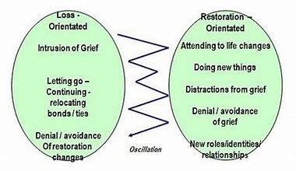

The diagram looks complicated but the idea is quite simple. On the left of the picture are activities which help us to feel the pain of loss, and on the right are activities which help us to find new ways of living without our loved one. You may find that you frequently bounce (or oscillate) between the two and this can happen minute by minute, hour by hour or day by day. It’s healthy and normal to move between the two sorts of activities, but also very common to find yourself spending most of your time on one side of the diagram. You may find that as time moves on you are more focused on ‘restoration orientated’ activities.
One final way of helping people to look at their grief was the model described by a psychotherapist from New Zealand called Lois Tonkin. She named it ‘Growing around Grief’, but other people usually call it ‘The Fried Egg Model’, because this is just what it looks like.

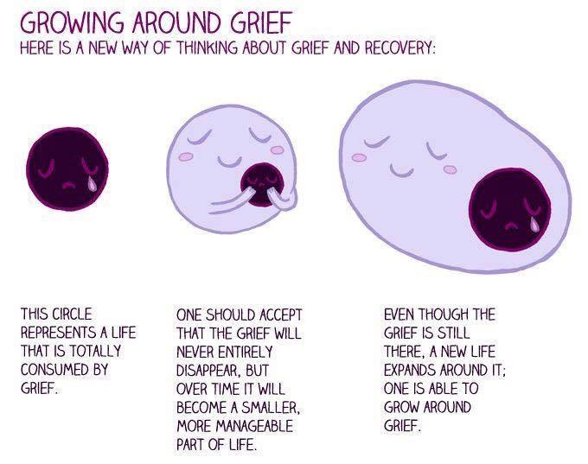

Immediately after your loss you may feel totally consumed by your grief, unable to think about anything else. People tend to think that over time grief will become smaller, and will take up less of your life, but Lois Tonkin suggests that what actually happens is that your grief stays the same size, but that you grow and expand around it in order to incorporate it into your life.

Exercise 3

You could take a few minutes to think about the models and try to decide which ones chime with you and which ones seem to have less in common with your own experience. Not all of the models will be meaningful to everyone.
When Grief is Complicated

We have already said that you will grieve at your own speed, but complicated grief is when the grieving process doesn’t move forward at all. You may feel completely “stuck”, too sad to get on with everyday life, or unable to connect with your sadness and grief at all. Complicated grief can last for a long period of time and be very intense. Sometimes it makes it very difficult to deal with working, socialising or running a house. Complicated grief may occur at any time in the grieving process.

If you are worried that you may be experiencing complicated grief, talking to a professional may help you to tell the difference between normal and complicated grief. You could talk to your GP, Cruse, your Bereavement Support Worker or your Bereavement Counsellor if you have one.

Cruse Bereavement Care: www.cruse.org.uk
Free helpline: 0808 808 1677

Grief and Your Relationships

Grief can have a big effect on how you interact with and feel about other people in your life. It can put a strain on existing relationships, especially if they were difficult in the first place or if people are grieving the loss in a different way to you.

Some people may be more sensitive to your feelings than others. Some may not recognise your sense of loss. You may have lost someone to an ongoing illness, so people may think that because you knew that the death was expected you will not be affected by it. They may also be trying to avoid the difficult feelings that the death brings about for them.

You may recognise some of these impacts on your relationships:

- You may become more irritable and grumpy than usual and find yourself being rude or offhand with other people. You may become angry when people try to make you feel better and say insensitive things.

- You might find it difficult to speak to people at times, especially if you often become tearful

- Your feelings may be very “raw” and near to the surface and this makes it easier for people to hurt you accidentally.

Despite these effects on your relationships it is important for your wellbeing to stay in touch with supportive people. Sometimes the people who help are not the most obvious ones – it may be that someone you are not that close to is the one who helps you through the bleak times.

It is common for family members to disagree and come into conflict after a loss. Some issues like funeral arrangements, wills and taking over caring responsibilities can be very sensitive, so it’s important to try to hear people out and make decisions together. Other family members may grieve differently to you, or appear not to be grieving at all. It might be helpful to talk about these differences in response to grief in order to find a way forward that works for everyone.

Relate. The Relationship People. www.relate.org.uk
Call: 0300 100 1234
Who Have You Lost?

You are in contact with Springhill Hospice Bereavement Service because you have lost someone to a life-limiting illness. You may have lost a life partner, a parent, a sibling, a child or someone who was close to you in some other way. Each of these bereavements will bring its own challenges and emotions.

Losing a partner creates unique challenges when it comes to learning to live without them. It may be that you find it difficult to cope with household tasks that your partner used to do, or responsibilities that they used to undertake and this can be overwhelming. You may feel that you don’t have the skills that you need to meet practical challenges on your own.

You may miss the closeness and intimacy of having your partner around. Not just in terms of sex, but also for hugs, cuddles and sharing a bed. Many people find this embarrassing to talk about, but it is a very real part of your loss. It may be that this is easier to talk about with a professional or another person who has lost a partner.

Losing a parent can be distressing at any age, even if you were expecting the loss. The loss of a person who has known you for your whole life can make you feel as though part of your identity has gone and part of your personal history has been lost. You may also feel that a significant connection to your family has gone. Relationships with siblings and surviving parents can be challenging as emotions run high. It can be difficult to explain the loss of a grandparent to your children when you are trying to handle your own grief.

If you have been caring for your parent, you may feel as though you have lost a purpose in your life. It can be difficult to fill the spare time that’s appeared in your life now that they have gone.

People who lose their parents later in life sometimes feel that they shouldn’t be upset because it is “normal” to lose an elderly parent, but this isn’t the case. Whatever your age, or their age, you are likely to feel lost or vulnerable after losing a parent. This may be exacerbated if you had a difficult relationship, or were estranged, and there are issues that were unresolved when your parent died.

Losing a child at any age is a devastating experience and can feel as though it has happened in the “wrong order”. Many parents feel that life has somehow lost its meaning and the plans and hopes which they had for their lives with their child in the future have now gone.

You have lost your child to a life-limiting illness. Parents often feel as though they are somehow to blame, and you may think that there is more you could have done to protect your child and keep them safe. These feelings may make it difficult for you to begin to move through your period of grief and mourning.

Losing a child can put a large amount of strain on your relationship. This is particularly true if you and your partner grieve in different ways, which can make it hard for you to move forward together. On the other hand some couples find that coping with the loss together can bring them closer.

If you have lost your only child this can be especially challenging as it changes the whole structure of your family, and you may feel that your identity as a parent is now uncertain.

Sometimes bereaved parents feel as though their bereavement is different to other sorts of loss and that it’s helpful to speak to people who are knowledgeable about this particular sort of loss. At the back of this guide we have included a list of specialist services who support families who have lost a child.

Losing a sibling is very difficult no matter what your age.

Adult siblings may experience complicated emotions around their loss. You may find it challenging to move forward, and support other siblings through their loss. You’re likely to be grieving in different ways, according to many factors, including your relationship with the sibling who has died. You are also likely to be spending a lot more time than usual with other siblings and this may be difficult. The loss of your sibling will change the dynamics and structure of your family and this means that remaining siblings have to adapt to changing roles in the family. The grief you feel at the loss of your sibling may be exacerbated by troubled or distant relationships within the family.

Younger children may find it difficult to understand what has happened. Springhill Hospice does not offer bereavement services for children who have experienced a loss. If you are concerned about how to support a child through a bereavement please see the section in this guide on talking to children about loss. There is a list of specialist children’s bereavement services at the back of the guide.

Losing a friend or someone you care about is difficult to cope with even if you have had time to prepare for the loss. If the person you have lost was part of your everyday life their death may leave a gap which is hard to fill.

It’s normal for you to have strong emotions when a close friend dies. Some people feel that they don’t have as much right to grieve as relatives or partners of the loved one, but this is not the case. You may have had a very strong bond, and it will take time to recover from your grief.

Talking to Children About Loss

Just like adults, children will react individually to their bereavement, and grieve in different ways. Their understanding of what has happened will vary according to their age. Younger children may have little comprehension of death and show curiosity without seeming to be upset.

The loss of someone significant may cause practical disruption to the daily lives of children. You have lost someone to a life limiting illness and this may have already meant changes to household routine, especially if you have had a caring role. This new disruption brought about by bereavement can be distressing and unsettling for children, and may also impact on their routines and important things such as exams, friendships and extra-curricular activities.

Conversations about death can seem daunting, and you may not feel confident about answering their questions. However, talking to children as simply and honestly as possible and correcting any misunderstandings they may have will help you cope together. It’s okay to let them know how your bereavement affects your own feelings and emotions and perhaps use this to ask them if they are worried about anything in particular. Some of their concerns and questions may seem trivial or even insensitive, but they may not understand the impact that this has on you. Don’t feel guilty if you find this distressing, but make some time for yourself after the conversation.
Child Bereavement UK www.childbereavementuk.org

Bereavement from Causes Other Than a Life-limiting Illness

Springhill Hospice is only able to offer bereavement support to people who have lost someone to a life limiting illness. However, we recognise that there are many other sorts of loss where specialist support can be helpful. For instance, if you have had a sudden, traumatic loss such as a road traffic accident or a suicide you may find it helpful to speak to specialists in such bereavements. For this reason we have included a list of other bereavement services at the end of this guide.

Taking Care of Yourself in Your Grief

So far in this guide we have focused on the process of grief and the things which you might expect to think and feel and the effects that these can have on your wellbeing and behaviour. Now we will look at things that you can do which may help you to cope with your grief.

You may have found that your behaviour has changed. You may be more withdrawn, lacking in energy and finding it hard to motivate yourself. Some people find that they start to neglect their health and wellbeing – they may not be eating well or getting out and about.

For these reasons it can be useful for you to try to create some structure in your day by making plans for things which you must do (like appointments), things which you enjoy doing (like hobbies), and spending time with loved ones. You could also include regular mealtimes and sleep routines in your plans, as eating and sleeping are both areas which tend to be difficult after the loss of a loved one.

Exercise 4
On the next page we have included a three day planner for you to complete. The purpose of this is to help you to look at how you are spending your time, and build in more of the activities which will help to keep you well and able to cope with your grief. It may help to give you some routine, structure and some activities to look forward to.

Try to complete the plan for a few days. It doesn’t have to be jam packed full of things in every space, and you should remember to set aside some time to relax and unwind, as this is important too.

The following pages suggest some helpful ideas and activities to help you to cope with your grief. Try to include as many of them as possible.
 | Day 1 | Day 2 | Day 3
Morning
Afternoon
Evening

What Helps?

Stay occupied as this can give your mind a rest from the difficult thoughts and feelings you have been dealing with. It’s important to think about your grief in order to work through what has happened, but sometimes you need a break, and keeping busy can improve your mood. It may be some time before you feel ready to build new routines and make big changes, but even small things like setting aside time to read a book or do some gardening can help.

Planning enjoyable events can help by giving you something to look forward to, and by distracting you from the difficulties you are experiencing. Something as simple as going to the cinema or planning a meal with friends can make a difference to the way you feel.

Reaching out to other people and asking for help or support can be difficult, and many people worry about asking for help as they feel that they may be a nuisance or cause inconvenience to other people. However, people often want to help, but don’t know what to do. It is a good idea to tell people what you would like from them. This might just be a chat, or it could be help with practical matters.

Looking after your physical health and keeping active, especially outdoors, is great for both mental and physical health. There is a lot of evidence to suggest that just going for a walk a few times a week can really boost your mood, sense of wellbeing, and overall fitness. If you make time for exercise on your planner you are more likely to be motivated to be active.

Making time for purposeful relaxation can be very helpful in the grief process. Activities such as meditation, yoga and crafts can distract you from your difficult thoughts and feelings for a while, and make you more able to cope when you return to everyday activities. There are many free online resources available to help you to relax. You could build time for relaxation into your daily planner.

Eating sensibly and trying to have a good sleep routine will both help you to stay physically well and be more able to cope with your feelings. Planning your meals, and putting a bedtime and getting up time on your planner may be helpful in motivating you to take better care of yourself.

Keeping in contact with family, friends and other important people will help you to cope with your loss. These are the people who are there on an everyday basis to support you through your bereavement. It may help to get a mobile phone if you don’t already have one as texting can be an easier way to communicate if you are struggling to talk about your feelings.

Talking about the person you have lost and enjoying your memories will help you to move forward in your grief. You might look at videos, photos, a ‘memory box’ or even make a scrapbook for you to look at and remember your loved one. You don’t have to talk about them all the time, but they have been an important part of your life and it will help to talk about them in the same way you talk about anyone else who is close to you.

You may also have to decide what to do with your loved one’s social media. Different social media sites have different policies, but it may be possible to have them memorialised so that you can still view their profile and read other people’s thoughts about them. You can also ask for the accounts to be deleted if you prefer.

Not expecting too much of yourself and your ability to cope with your loss will make it easier to cope with. Try not to hurry the healing process, and take things at your own pace. It’s probably not a good idea to make big decisions, such as moving house, whilst you are in the early stages of grief.

Taking time for your feelings is important because you have to spend time with them in order to progress through your grief journey. If you are struggling with your emotions, trying to push them away can be unhelpful. Instead it can help to sit with your feelings and find some way of expressing them.

It can be helpful to write your thoughts and feelings down, and for this reason people sometimes keep a journal, or an emotional diary. If that sounds too ambitious you could keep a notebook with you and just jot down anything which feels important to you. You might also use this information in your planner, as you notice which activities help to make you feel stronger.

Some people prefer not to write, and if it is easier you could use the voice recorder on your phone or make a photo graphic record. The important thing is to look at your feelings as doing this is part of your grief journey.

Celebrating and honouring your loved one is an important way of acknowledging what they mean, and meant, to you and other people. Significant dates, such as anniversaries and birthdays, can be difficult to deal with. It’s tempting to put on a brave face and pretend that everything is alright, but it may be better to put aside some time to think about your loss. On celebrations days such as Christmas, you may try to reproduce your normal day, but take time out to acknowledge your loved one, by visiting their grave for example. Alternatively, you may decide to do something completely different or have a scaled down version of your normal day. There is no right or wrong way to behave.

Not everyone has a grave or headstone to visit on anniversaries, and it may be helpful to keep a ‘memory box’ of mementoes and photos of your loved one to look at.

Significant dates can feel like painful reminders of how things used to be. It can be helpful to plan ahead, and keep busy, to make the day easier to cope with. It can also be useful to spend this time with other people who can support you through difficult times. Talking about your loved one with them will help to keep your memories alive.

Alcohol and drugs are best avoided if you are feeling low. People who have had a significant bereavement can be vulnerable to alcohol and drug misuse, but this won’t help you to come to terms with your loss in the long term.

Not Being Able to Say Goodbye.

Not having the chance to say goodbye to your loved one can make it particularly hard to grieve. This has been especially so for people during the global COVID-19 pandemic when people have been unable to visit dying friends and relatives, and often unable to attend their funeral.

The COVID-19 pandemic is changing our traditional ways of marking our losses and physical distancing means that our usual practices of saying goodbye are disrupted. People are finding different ways of expressing their feelings - for example, visiting and talking to their loved one’s grave or taking part in an online memorial service. Social distancing measures permitting, it may help to organise a gathering in the future to talk about your loved one and honour their life. You may feel more comfortable doing something privately, and this might include writing a letter to your loved one to tell them the things you would have said if you had been able to say goodbye in person.

Religion, Faith and Spirituality

If you have a religion or faith it can be helpful during your bereavement. Rituals and practices for grieving can provide comfort, offer closure and opportunities to say goodbye. Your religious, faith or spiritual leader will be able to offer advice on resources and support in your area, and may often be able to provide valuable support themselves.

It’s common for people who have lost a loved one to feel angry or conflicted about their faith, and this isn’t something to feel guilty about – it is part of the grieving process. It may be helpful to talk to your spiritual leader about this.

Deciding if you need further help and support.

We hope that this guide may have provided some reassurance that your feelings around your loss and grief are normal. Not everyone needs to seek out additional or professional support during this difficult time. It may be that the help you receive from your usual social network of family and friends is sufficient to see you through. If you combine this with the techniques and ideas that you have found useful in this guide, you should continue to benefit and move forward in your grief.

If you do feel that it would be helpful to speak to someone with specialist bereavement knowledge, someone who has been through a similar bereavement, or from outside your normal social circle, we have some suggestions below.

Specialist Bereavement Services

Springhill Hospice
Here at Springhill Hospice we offer a range of bereavement services according to the needs of our clients. These include information, volunteer support, peer support groups and one to one counselling. We will discuss your bereavement needs with you when you first make contact with us.

On the next few pages you will find a list of bereavement resources and services. Some organisations support people who have experienced a particular sort of bereavement, whilst others offer more general bereavement support.

We have also included links to other helpful online resources.

BEREAVEMENT SERVICES
General Support
- Cruse Bereavement Care: adults and children
1:1 bereavement support
https://www.cruse.org.uk/
Free helpline 0808 808 1677

- Andy’s Man Club, Rochdale: men
Bereavement support group
Email: info@andysmanclub.co.uk
http://andysmanclub.co.uk/

- Widowed and Young: bereaved women and men aged 50 and under
1:1 telephone and group support
https://www.widowedandyoung.org.uk/
https://way-up.co.uk/ age 50s and 60s

- Rochdale Women's Welfare Association: women of all ethnicities for general counselling including bereavement
Rochdale Women’s Welfare Association
18 Trafalgar Street, Rochdale. OL16 2EB
Tel: 01706 860157
www.rwwa.org.uk

Supporting Bereaved Children and Loss of a Child
- Child Bereavement UK: children and young people (up to age 25), parents, and families when a child grieves or when a child dies
1:1 and group bereavement support
https://www.childbereavementuk.org/
0800 02 888 40

- Child Death Helpline: for those affected by the death of a child
1:1 telephone bereavement support
http://childdeathhelpline.org.uk/
Free phones 0800 282 986 | 0808 800 6019

- Compassionate Friends: bereaved parents
1:1 telephone and group bereavement support for parents
www.tcf.org.uk
Tel: 0345 123 2304

- Hope Again: young people living after loss
1:1 telephone, face-to-face and group bereavement support
https://www.hopeagain.org.uk/

- Lullaby Trust: sudden and unexpected death of a baby or young child
1:1 telephone bereavement support
https://www.lullabytrust.org.uk/
Freephone 0808 802 6868
- SANDS: bereaved by the death of a baby
1:1 telephone and group support
Tel: 0808 164 3332
www.sands.org.uk

- Once Upon a Smile: family bereavement support
1:1 counselling and monthly support group
Sidley House, 6 Brindley Road, Manchester. M16 9HQ
Tel: 0161 711 0339
https://www.onceuponasmile.org.uk/what-we-do/childrens-bereavement-support-groups/

- Grief Talk: family and child bereavement support
1:1 counselling and group counselling
Tel: 0808 802 0111 (9am to 9pm)
Email: grieftalk@griefencounter.org.uk
www.griefencounter.org.uk

Sudden or Unexpected Death

- SUDDEN: Immediately after COVID-19 death or any sudden or too soon death
Helpline: 0800 2600 400
Email: help@sudden.org
https://www.sudden.org

Bereaved by Suicide

- Survivors of Bereavement by Suicide (SOBS)
1:1 helpline and groups
Helpline 0300 111 5065
https://uksobs.org/

